LESSON 5.1: COMPARING

- PAIR WORK
Choose a gadget that you use in your everyday life and discuss how it has changed during your lifetime. What improvements have been made to the design, functioning, etc. Present your work to the class.

- COMPREHENSION: Watch the video “Technology Then and Now”
- List the different technologies that are compared.

- Look at these sentences about the technologies and try to remember the missing information. If not, take a guess. Then watch the video again and check your answers.
- Ebook readers: the cheapest version can hold ________ books in digital form
- Cars: the 1908 model had a top speed of ________ mph. The 2017 model has a top speed of ________ mph.
- Laptops: the first laptop had a ________-inch screen and weighed ________ pounds. The new models have 13-15-inch screens.
- Mobile phones: the 1973 model weighed ________ kg and took ________ hours to recharge.

- Read the sentences and say what they are about.
- This modern model has a longer talk time than the old model.
- It’s the best gadget for reading.
- This gadget is the most multifunctional of all the objects shown in the video.
- This gadget has the biggest screen.
- The modern model has a more powerful engine than the old one.
- This is the heaviest thing in the video.
- Some people say that it’s worse for your eyes than the paper version.

- GRAMMAR: Comparatives and superlatives
- Look at the sentences from exercise 3 and answer the questions.
COMPARATIVES
- Which sentences compare two things?
- Which two letters do we add to short adjectives (eg. long)?
- Which word do we use before long adjectives (eg. powerful)?
- Which word do we use after the adjective when we compare two things?
SUPERLATIVES
- Which sentences compare more than two things?
- Which three letters do we add to short adjectives?
- Which word do we use before long adjectives?
- Which word do we use before short adjectives and before most+ long adjectives?
IRREGLAR ADJECTIVES
How are these adjectives different?
- big
- heavy
- good/bad
- Complete the table based on the answers in exercise 1.
 | SHORT ADJECTIVES (ONE SYLLABLE) | ADJECTIVES WITH TWO SYLLABLES, ENDING IN -Y | LONG ADJECTIVES (TWO OR MORE SYLLABLES) | IRREGULAR ADJECTIVES
COMPARATIVE | -er (than) | -ier (than) | More (than) | -Better -worse  further -less
SUPERLATIVE | (The) -est | (the) -iest | (the) most | -best -worst --furthest -least

- Put the words in brackets in the correct form
- I think I need a new phone. I want one with a bigger screen than my old one (big)
- If you want to impress them, buy this tablet. It’s the most expensive one in the store. (expensive)
- They upgraded their computers to the ones with a faster processor. (fast)
- My smartwatch has really helped me to be healthier than before. I move more and I’m in better shape. (healthy, good)
- This is the worst phone I’ve ever used. The battery is always low and the camera takes terrible pictures. (bad)
- Out of all music subscription services, this one is the most convenient they have good UI, and the price is the cheapest, too. (convenient, cheap)

- Use comparative and superlative forms to compare the following objects. Discuss with a partner and write down 5 or 6 sentences.
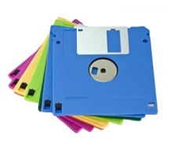 | 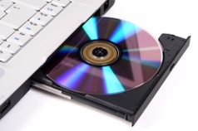 | 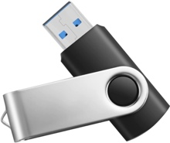 |  | 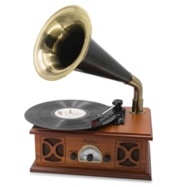 | 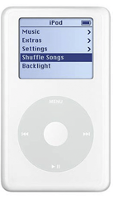 | 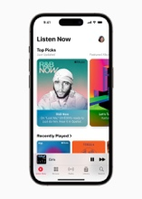
floppy disk | compact disk | memory stick |  | record player | first-generation iPod | modern smartphone

- Read the product description below, then read this blogpost (https://web.archive.org/web/20160424001716/https://writtent.com/blog/write-product-descriptions-sell/) paying especial attention to the section on superlatives.
Roku Streaming Stick+
Exceptional wireless. Stunning picture quality. Start watching your favorites quickly and enjoy a smooth streaming experience. Whether you’re streaming in your home, hotel or even in the backyard, the advanced wireless receiver gives you 4x the range and a stronger signal for streaming. This means you can stream in places that are ordinarily too far from the router. Stream in brilliant 4K, HDR and HD. Experience the visual rush of 4K and vibrant HDR picture quality with the new powerful and portable streaming Stick Plus. plus, no more juggling remotes. Our new voice remote with buttons for TV Power and volume control makes it easy to control both your TV and streaming Stick Plus. Enjoy 500, 000 Plus movies and TV episodes across thousands of free or paid channels. You can even search by voice across top channels by actor, show and more.
Now write a product description for one of the following objects:
Kindle Paperwhite, 8GB, 6;8” Display
Samsung 75” Crystal 4K Smart TV
Beats Studio3 Wireless Noise Cancelling Headphones
Echo Dot Smart Speaker with Alexa
AMD Ryzen 9 Processor, 3.4 GHz
With the arrival of the first Ryzen 9 processors in 2019, AMD expanded its ability to rival the performance of competing Core i7 and Core i9 chips from Intel. If you're in the market for the ultimate high-performance, consumer-grade desktop CPU, the Ryzen 9 and Core i9 are both compelling options. In 2021, new second-generation Ryzen 9s in the Ryzen 5000 Series (headed up by the ferociously powerful 16-core AMD Ryzen 9 5950X) have taken the fight to the latest Core i9s. (The Core i9 is now in the 10th and 11th Generations on a new-for-2020 platform, the LGA1200.)

